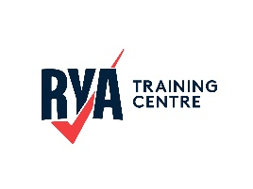

Course Plan

Start Racing Lesson Plan
This course is generally run as part of the Club’s Friday night ‘Sail Training sessions

Session 1
- Starts
  - Understands a basic start sequence
  - Can identify a start line and start from the correct side Boat Handling
  - Can tack and gybe in a range of conditions
  - Understands the use of heel and trim to aid steering Speed
  - Can use the five essentials effectively
  - Can keep the boat upright using the toe straps to sit out and can trim the sail to aid this Tactics
  - IRPCS

Session 2
- Starts
  - Can slow the boat and accelerate to cross the line within 10 seconds after the start signal Boat Handling
  - Understands an appropriate technique to approach and land when coming ashore, on lee shore, weather shores or slipways Speed
  - Can use the five essentials effectively
  - Can hold an effective close-hauled course upwind Tactics
  - RRS Strategy
  - Can source and use an appropriate weather forecast

Session 3
- Starts
  - Understands the procedure if over the line at the start Boat Handling
  - Can recover from a capsize with little assistance Speed
  - Can hold an effective close-hauled course Tactics
  - Understand how to round a mark
  - RRS Strategy
  - Understands what a suitable wind strength is to race in

Session 4
- Starts
  - Understands the significance of port/starboard and windward/leeward Boat Handling
  - Can perform an MOB recovery to Level 2 standard Speed
  - Can use the five essentials effectively Tactics
  - Can recognise headers and lift

