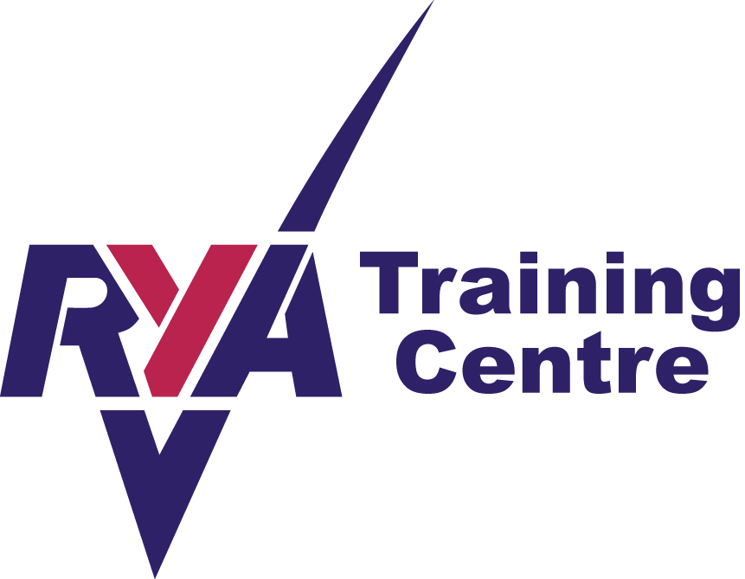
WELLAND YACHT CLUB
River Bank, Spalding, Lincolnshire, PE11 3AA
Affiliated to the Royal Yachting Association

RYA LEVEL 2 NATIONAL POWERBOAT COURSE

PRE COURSE INFORMATION

This course is designed to provide the skills and background knowledge needed by the competent powerboat driver and is the basis of the International Certificate of Competence. The course teaches you how to drive the craft responsibly but above all safely and still having maximum enjoyment.

Course content
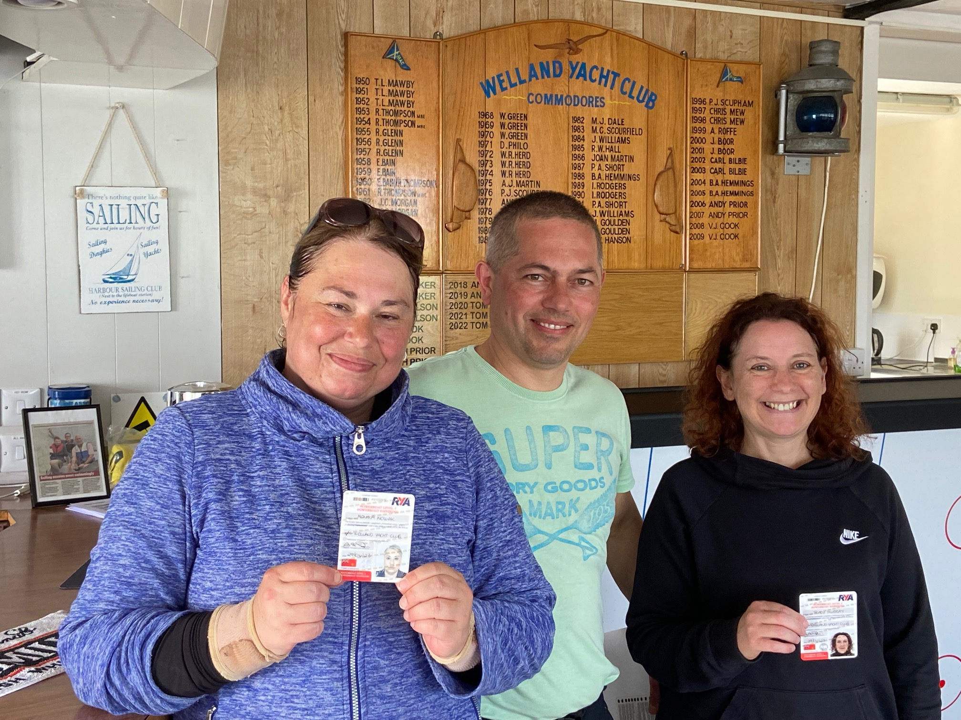
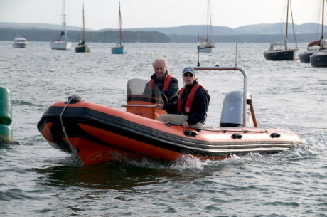
Preparation – launching and recovering; safety equipment, lines and fenders and fuel tanks
Boat handling – high and low speed manoeuvring; propeller controls; securing to a buoy; anchoring; leaving and coming alongside and man over board
Theory & Background – types of craft and engine, maintenance checks; IRPCS, navigation; weather forecasts and emergency action

Facilities and equipment
You will be using a console-steered Fuyak boat. The Welland Yacht Club and the River Welland offer a varied learning environment to ensure all your tuition needs are met.
Please bring suitable clothing including wind and waterproofs with you.

Lunch
Lunch is not available so please bring a packed lunch which may be eaten in our well-equipped clubhouse.

Pre Requisites
The minimum age is 12 years old. Under 16s will be issued with an endorsed certificate stating – The holder should only use powered craft under the supervision of a responsible adult. No Experience is needed to be able to complete this course.

Duration
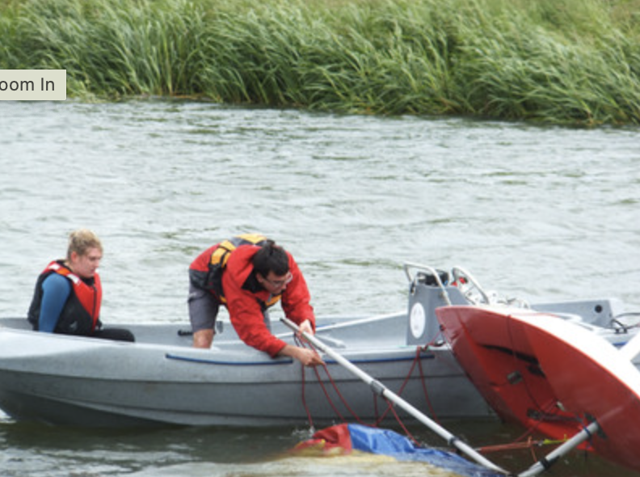
The course is a 2 day course and will include approximately 16 hours traing.
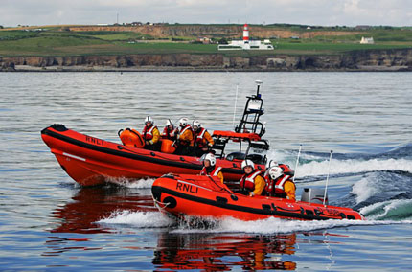
Running times
9.00-12.30 Session 1
12.30-1.00 Lunch
1.00-5.30 Session 2

Cost
£250 Per person with 2 people or more (plus cost of certificate)
£300 One To One

Course dates
Please enquire at Welland Yacht Club or on our website – www.wellandyachtclub.co.uk.

General
Please arrive early on the first day of your course to allow time for booking in and introductions to be done. Although Welland Yacht Club endeavours never to cancel a course please be aware that sessions are subject to appropriate safe weather conditions.

The next step
When you have completed the Level 2 course and are actively involved in a watersports environment with a club or organization you may wish to think about working towards your Safety Boat qualification.

