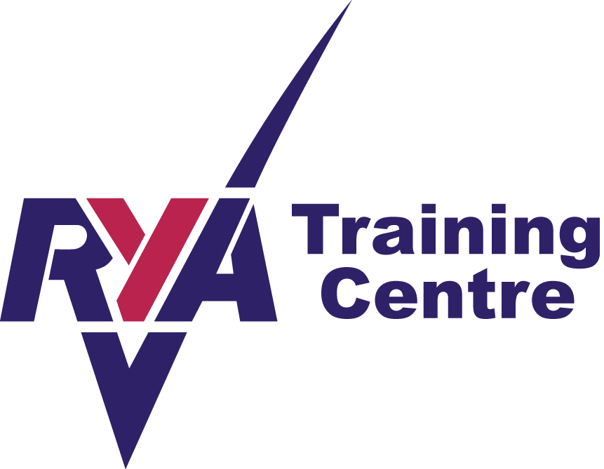
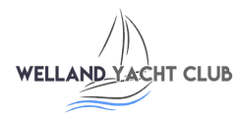
WELLAND YACHT CLUB
River Bank, Spalding, Lincolnshire, PE11 3AA
Affiliated to the Royal Yachting Association

RYA LEVEL 2 NATIONAL SAFETY BOAT COURSE

PRE COURSE INFORMATION

This two-day course provides the skills required when acting as an escort craft, safety boat or coach boat for a fleet of dinghies, windsurfers or canoes, or for racing or training activities. It includes rescue techniques and elements of race management and mark laying. It is strongly recommended that a member of the rescue crew should hold a first aid certificate (or should have experience of first aid).

Course content
Preparation, boat handling, dinghy rescue, windsurfer rescue, kayak or canoe rescue (can be covered as theory), towing, end-of-day procedures, safety, suitability of craft, local factors, communication, rescuing other water users

Facilities and equipment
You will be using a console-steered Fun Yak boat. The Welland Yacht Club and the River Welland offer a varied learning environment to ensure all your tuition needs are met.
Please bring suitable clothing including wind and waterproofs with you.

Lunch
Lunch is not available so please bring a packed lunch which may be eaten in our well-equipped clubhouse.

Pre Requisites
The minimum age is 16 years old.

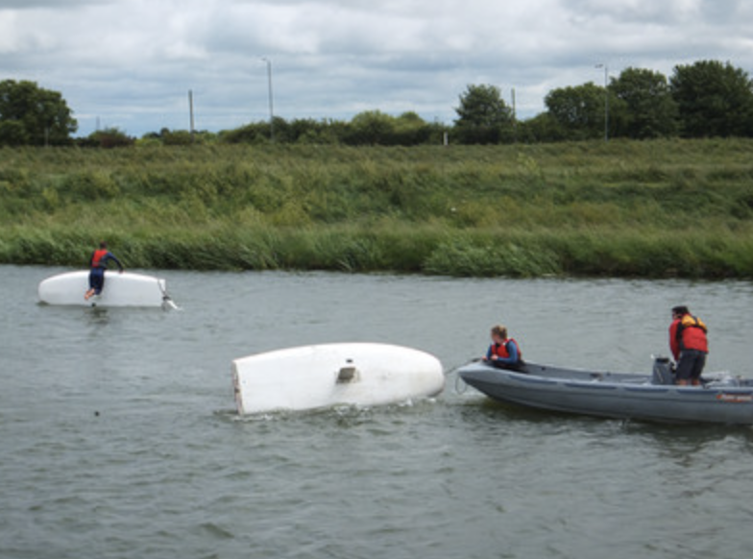
Duration
The course is a 2 day course and will include approximately 16 hours training.

Running times
9.00-12.30 Session 1
12.30-1.00 Lunch
1.00-5.30 Session 2

Cost
£250 Per person with 2 people or more (plus the cost of the certificate if required)
£300 One To One

Course dates
Please enquire at Welland Yacht Club or on our website – www.wellandyachtclub.co.uk.

General
Please arrive early on the first day of your course to allow time for booking in and introductions to be done. Although Welland Yacht Club endeavours never to cancel a course please be aware that sessions are subject to appropriate safe weather conditions.

